At first, it was planned that a breadboard and wire jumpers will be used for the sumo-bot, however we found that it is an inefficient and unreliable method; as the robot is vulnerable to mechanical vibrations when it is in motion, which can cause some of the electronic components to be disconnected, so errors might be experienced. Also, there are multiple connections used in a very small area, which makes it more difficult for us to trace the electrical connections are made correctly or not while testing the prototype. As shown in the following picture:

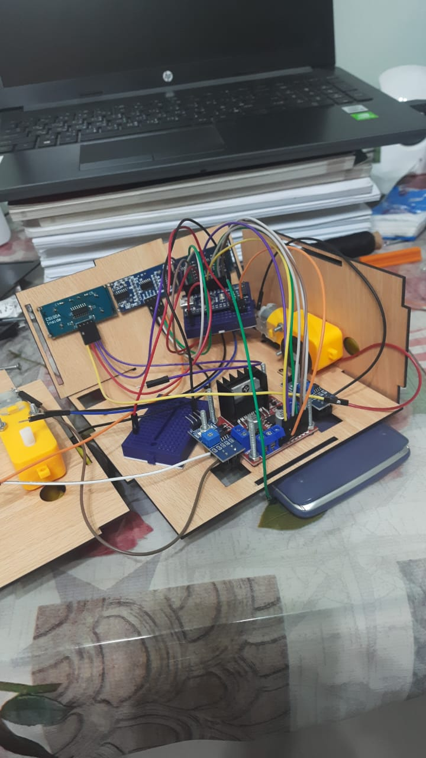

That is why a PCB is designed consisting of all of the inputs (sensors) and outputs (motors) in a compact size, in order to ensure that the circuit is stable so the robot can continuously operate without experiencing any loose connections or electronic noise. As shown in the next picture:

Sort el PCB alaa 7teb3atha

Besides, we used Arduino nano instead of Arduino uno, because it is smaller in size which easily fits inside the robot model and has greater number of ports which we found more suitable for our robot, because of having many electrical connections.

We were in a debate of whether it is better to use three ultrasonic sensors or two IR sensors with a single ultrasonic sensor on the front top part of the robot, in order to increase the robot’s accuracy in detecting the opponent robot.

Then after doing our research, we discovered that using more than one ultrasonic sensor can cause inaccurate results, because they are very susceptible to noise due to many sound waves being transferred and received in the same range where this interference makes it difficult or impossible to measure the distance. Also, the opponents’ robots might be smaller than ours and may have odd shapes that would not reflect the ultrasonic waves, which is another difficulty encountered. That is why we used a single ultrasonic sensor to have reliable results by measuring the distance accurately and two IR sensors to easily detect any smaller robots accurately since it is faster in response and has much more focused beams that is not easily interfered with. As shown in the following figure:

Sort el solidworks ll robot mn odam

We used 4 IR sensors (TCRT5000) at the bottom of the robot to ensure that the robot won’t get out of the black field. There are two IR sensors located on the front bottom to check if the white ring is in front of it, so it can avoid it by turning to the right or to the left also the two IR sensors on the back bottom have the same rule for detecting the white ring but if it is behind the robot. As shown in the figure:

Soort el solidworks el reda 7yeb3atha bs mn gowa y3nee mbyna amaken el IR sensors el t7t

Lithium batteries are used because it is cheap and gives out high current